Community Voice: BC's African-American Success Through Excellence and Persistence (ASTEP) program
By Paula L. Parks
MONDAY, JUL 11, 2016 5:28 PM 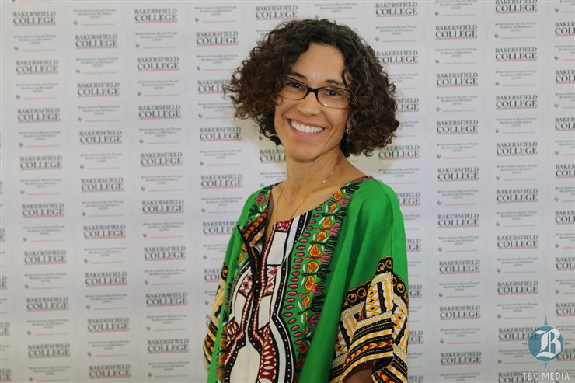
Paula L. Parks, PhD, is an English professor at Bakersfield College and coordinator of the ASTEP program. For more information, contact pparks@bakersfieldcollege.edu. Also check out ASTEP at Bakersfield College on Facebook.
Summers are a relaxing time for many educators.
For me, it is also a happy time as I recall the tremendous academic and personal growth I witnessed in my ASTEP students last school year. They were the first group of students to participate in BC's African-American Success Through Excellence and Persistence (ASTEP) program.
In the spirit of equity, Bakersfield College offers programs for groups, such as low income students, first generation students, veterans, foster youth, Hispanic/Latino/a, and African Americans. BC administrators know how important it is to provide support in order to produce graduation and transfer rates that strengthen our local community.
ASTEP has a comprehensive approach to support that includes coursework, required study sessions, time with BC and community mentors, cultural and academic trips, and appointments with the ASTEP counselor so that students stay on track to graduate.
The English classes offered through ASTEP are designed to be culturally relevant and engaging. Research shows that culture is a source of strength and motivation. ASTEP students deepened their knowledge and appreciation of their African-American heritage and worked diligently to craft quality essays and research papers. As a result, students in ASTEP passed their English classes at four times the rate of Black students not in the program.
Other programs around the state are seeing similar success rates — 75 percent to 90 percent of students passing and very few dropping out. El Camino College's Project Success in Los Angeles and Chabot College's Daraja Program in Hayward have 25-30 years of impressive data. The state-wide organization called Umoja (a Swahili word meaning unity) offers conferences that empower and motivate students to graduate as well as professional development that guides coordinators and staff.
My ASTEP English classes were designed as a safe space for spirited debates about issues in the African-American community. I saw students blossom into their best selves. They formed a community of scholars, who studied together, reminded each other about homework, and gave each other rides. The students — new, continuing, and returning — ranged in age from 18 to 50-something and were always learning from each other.
I am indebted to the Bakersfield community, which has been instrumental in the program's success. Involvement has ranged from groups who invited students to attend their events to individuals who volunteered to mentor a student. During the school year, students attended the NAACP awards gala, the Entrepreneur Extravaganza, and the Kern County Black Chamber of Commerce gala. They sat at the BC table at Project BEST's 25th anniversary celebration and Alpha Phi Alpha Fraternity, Inc.'s 8th annual Black and Gold Scholarship Banquet.
Students who took advantage of such opportunities were exposed to professionals and ideas with which they would not have had a chance to engage. When we attended events, I always told my students to take notes and to meet someone so that they would get the most from every occasion.
I am also grateful to the ASTEP mentors who were an important part of the program as well. They included BC faculty and staff as well as community members who took time to connect with students. Last year's BC mentors included Program Manager Karla Young, Professor Valerie Robinson, BC Nurse Debra Strong, and VP of Finance Dr. Anthony Culpepper. Community mentors included La Shane Williams, Maurice Randall, Diane McClanahan, Arleana Frink Waller, Dena Freeman-Patton, Gina Gordon Lopez, Otis Warren, Shirley Gordon, and Karen Coston. They invited students to their workplaces, met them for lunch, joined them at ASTEP events, dropped by their homes, provided general motivation and career information, and were role models of professionalism.
That first ASTEP group was so special and working with them was incredibly fulfilling. I told them that "ASTEP is a family; you'll graduate from BC, but not from ASTEP." So, I look forward to fall; many are taking ASTEP2, a special projects class that will offer them a chance to take their game to the next level by engaging the BC community and the Bakersfield community.
I also expect they'll be peer mentors for this next group starting in August. The class is almost full, and as I anticipate teaching and supporting the second ASTEP group, my happiness grows even more.
Paula L. Parks, PhD, is an English professor at Bakersfield College and coordinator of the ASTEP program. For more information, contact pparks@bakersfieldcollege.edu. Also check out ASTEP at Bakersfield College on Facebook.

